# The modern mode, "use strict"

## [“use strict”](https://javascript.info/strict-mode" \l "use-strict)

The directive looks like a string: "use strict" or 'use strict'. When it is located at the top of a script, the whole script works the “modern” way.

# Data types

## [String](https://javascript.info/types" \l "string)

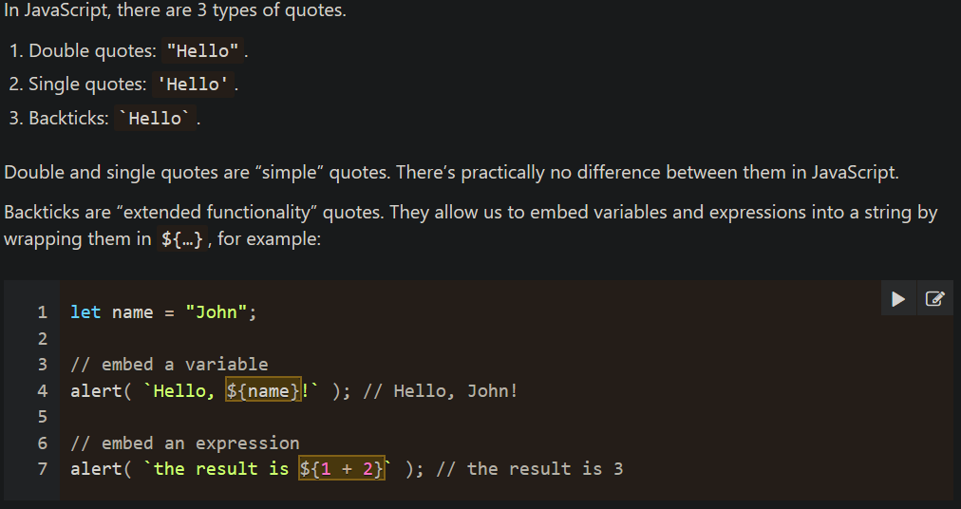

# Type Conversions

## [Numeric Conversion](https://javascript.info/type-conversions" \l "numeric-conversion)

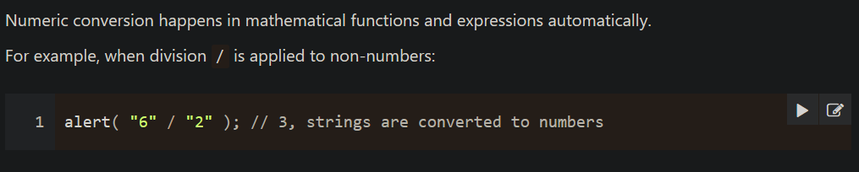

# Operators

## [Numeric conversion, unary +](https://javascript.info/operators" \l "numeric-conversion-unary)

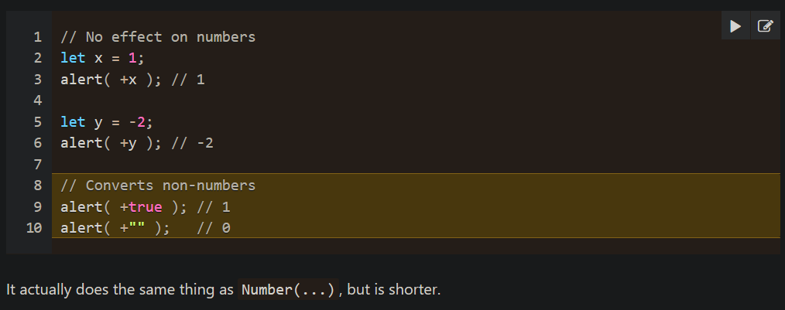

# Comparisons

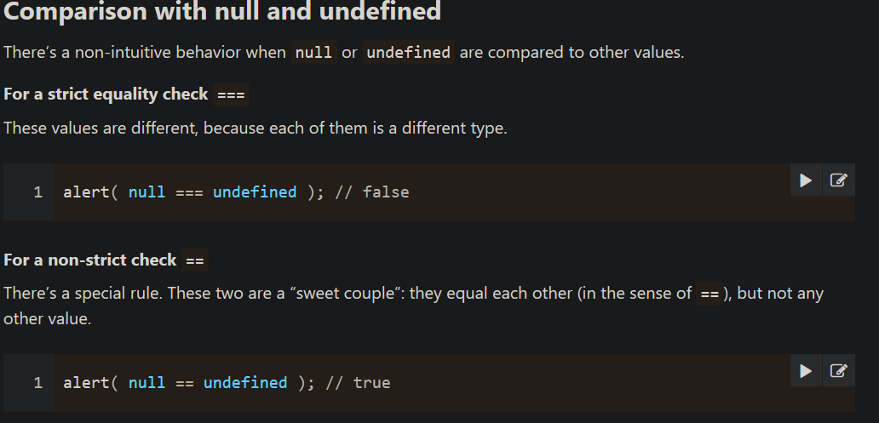

# Loops: while and for

[**Labels for break/continue**](https://javascript.info/while-for#labels-for-break-continue)

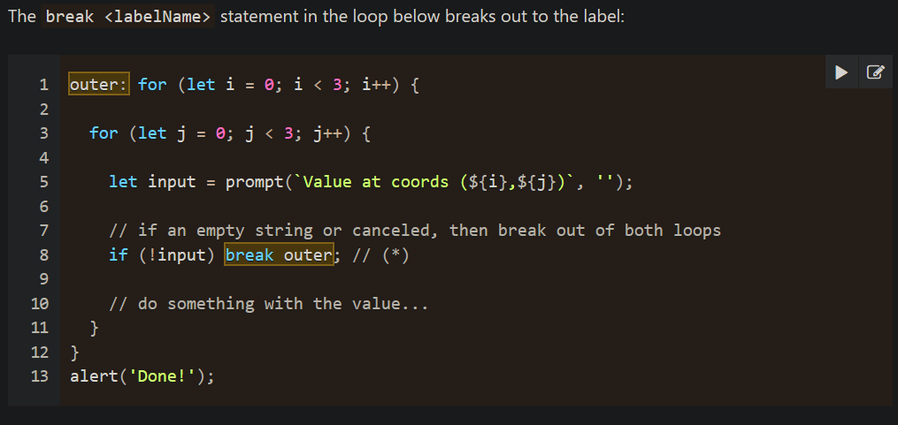

Functions Basics

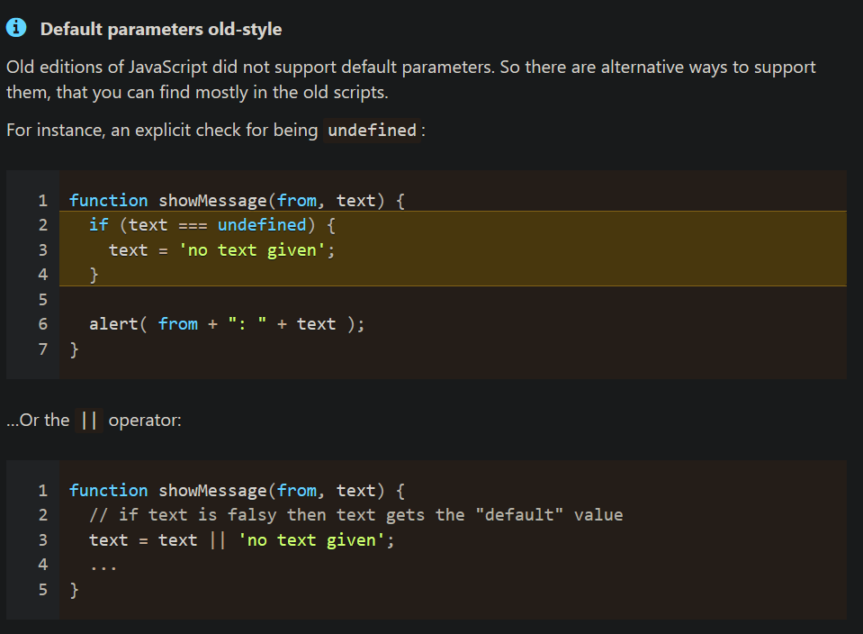

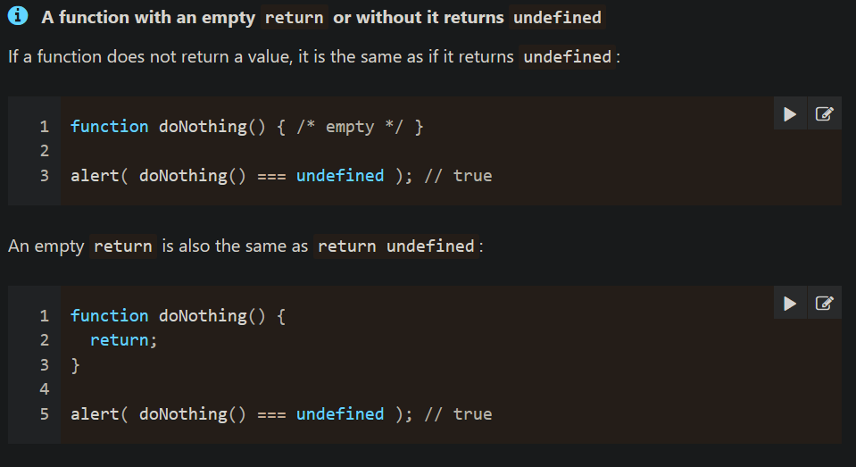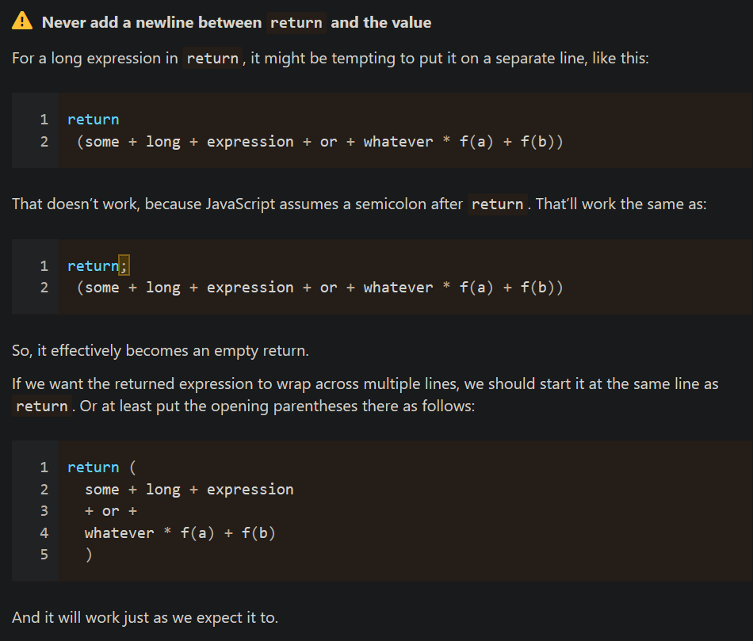

# Function expressions

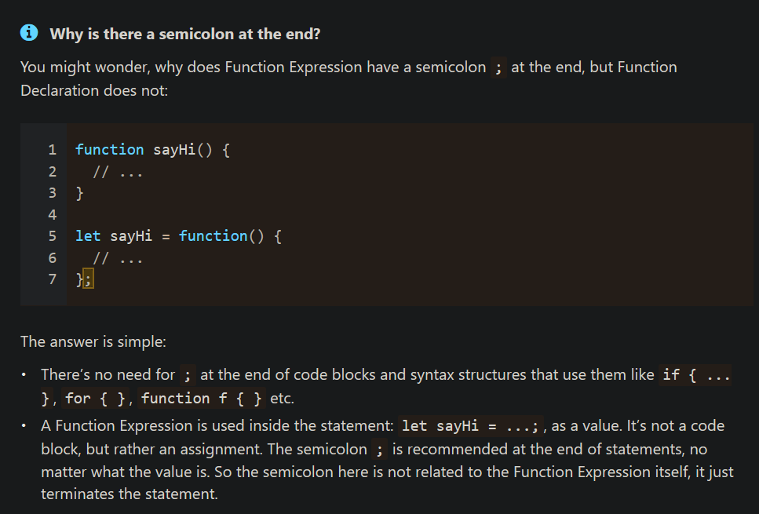

## [Function Expression vs Function Declaration](https://javascript.info/function-expressions" \l "function-expression-vs-function-declaration)

1. **Created by the JavaScript engine.**
   1. **A Function Expression is created when the execution reaches it and is usable only from that moment.**
   2. **A Function Declaration can be called earlier than it is defined.**
2. **Block scope.**
   1. **In strict mode, when a Function Declaration is within a code block, it’s visible everywhere inside that block. But not outside of it.**